**HTTP**

* **WHAT IS HTTP**
* **Hyper Text Transfer Protocol**
* Communication between web servers & Clients
* HTTP Requests /Responses
* Loading pages, from submit, Ajax calls
* **HTTP IS STATELESS**
* Every Request is completely **independent**
* Similar to transactions
* Programming, Local Storage, Cookies, Sessions are used to create enhanced user experiences.
* WHAT IS HTTPS
* Hyper Text Transfer Protocol Secure
* Data sent is encrypted
* SSL / TLS
* Install certificate on web host
* HTTP METHODS
* **GET**

Retrieves data from the server

* **POST**

Submit data to the server

* **PUT**

Update data already on the Server

* **DELETE**

Deletes data from the server

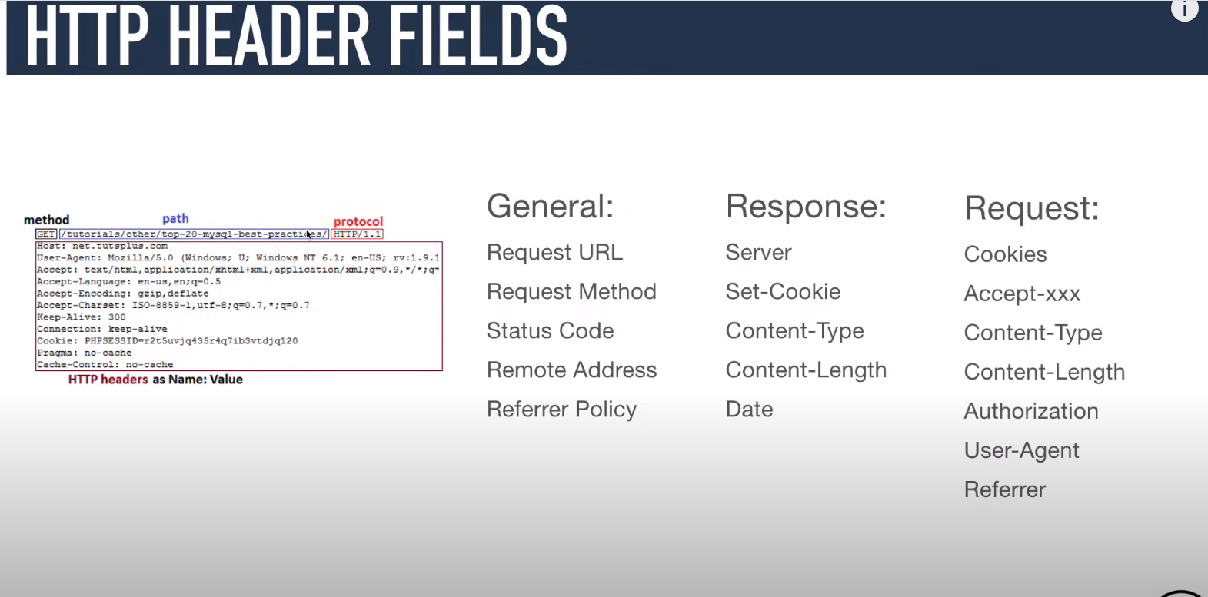

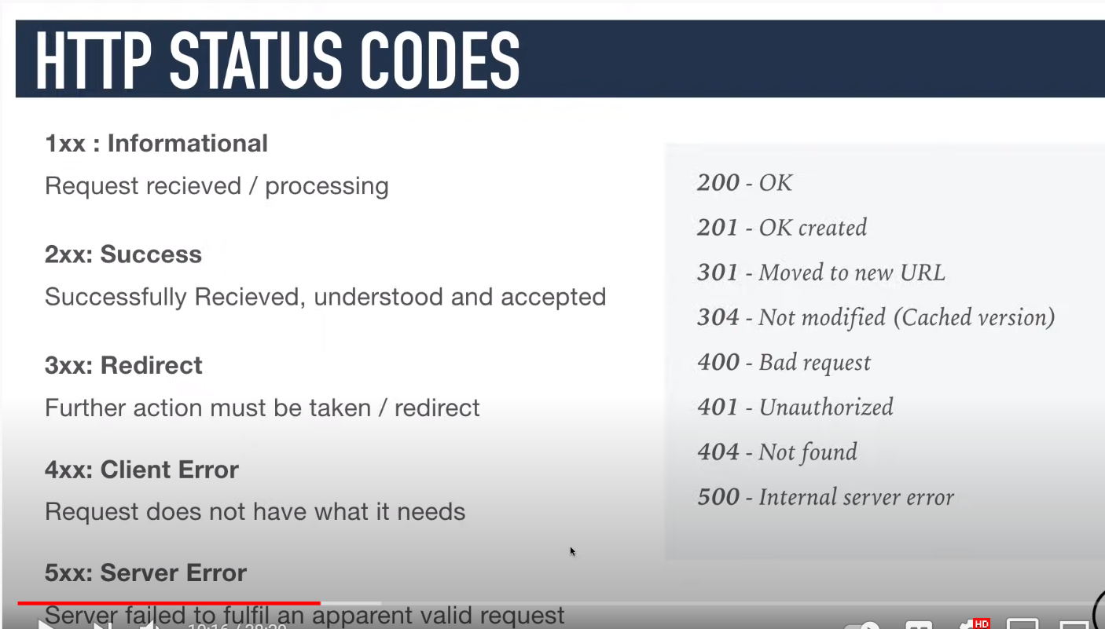

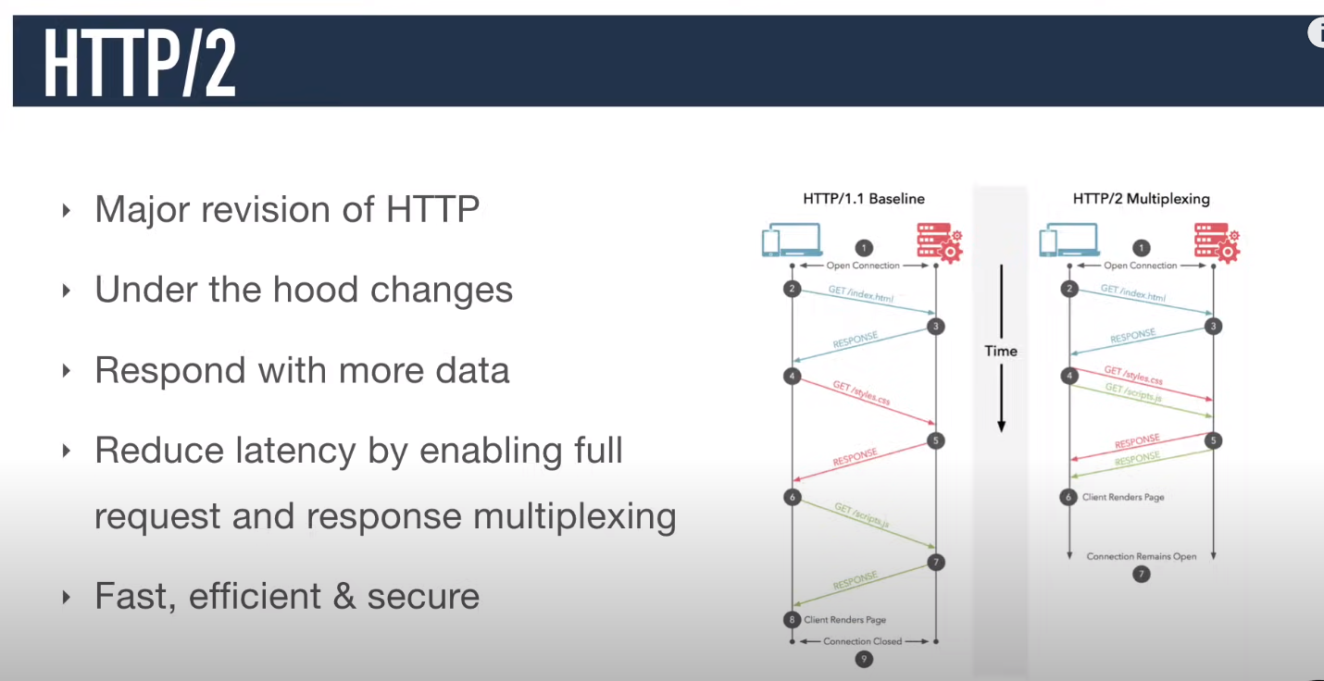

* Here we see all types of document file, CSS file, html file script file if we want to check it then we have a option to open all this file.

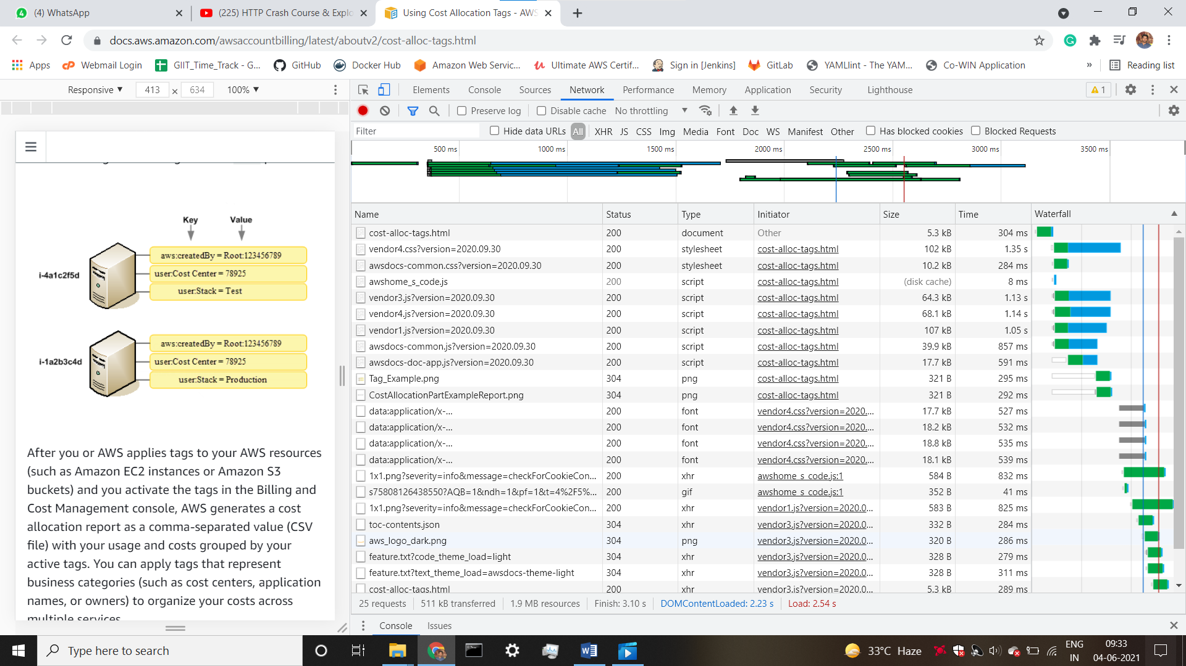

* If we want to check header response we have a option to check all the things here.

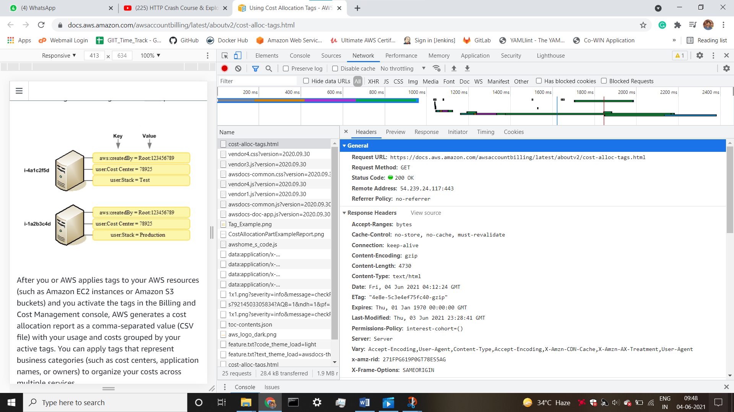

* Install postman and create new workspace

